Project Plan
for
RecruitMe Enterprise
Application
Version 2.0
Prepared by Ganith Perera, Naduni Pulsarani
RecruitMe
05/10/2017

Project Plan Approval Signatures

Project Name: RecruitMe Enterprise Application

The undersigned acknowledge they have reviewed the, RecruitMe Enterprise Application Project Management Plan and agree with the approach it presents. Changes to this Project Management Plan will be coordinated with and approved by the undersigned or their designated representatives.
Signature: |  | Date: | 10-05-2017
Print Name: | Ganith Perera
Title: | Mr.
Role: | Tech Lead  System Analyst

Signature: |  | Date: | 10-05-2017
Print Name: | Naduni Pulsarani
Title: | Miss.
Role: | Project Manager  Quality Assurance Lead  System Analyst

VERSION HISTORY

The following is the document control for revisions to this document.

Version  # | Implemented  By | Revision  Date | Approved  By | Approval  Date | Reason
1.0 | Ganith Perera  Naduni Pulsarani | 01/05/2017 | Ganith Perera  Naduni Pulsarani | 04/05/2017 | Initial DocumentProject Plan
2.0 | Ganith Perera  Naduni Pulsarani | 08-05-2017 | Ganith Perera  Naduni Pulsarani | 10-05-2017 | Review & finalized

Table of Contents

Project Plan Approval Signatures ii
VERSION HISTORY iii
1. Purpose 5
2. Project Schedule 5
2.1. Gantt Chart 5
2.2. Project Schedule 7

- Purpose

Project plan tells everyone where you are going and how you are going to get project life cycle and the project plan is at the heart of the project life cycle. This presents the detail required to successfully execute and control the project, facilitate communication among project stakeholders. Project plan document is a living document and it is expected to change over time as more details about the project becomes available.

- Project Schedule

This section includes the Gantt Chart and the Project Schedule for the RecruitMe Project.

  - Gantt Chart

The Gantt Chart graphically represents a RecruitMe project by showing each task of all team members as a horizontal bar.

RecruitMe Enterprise Application Project

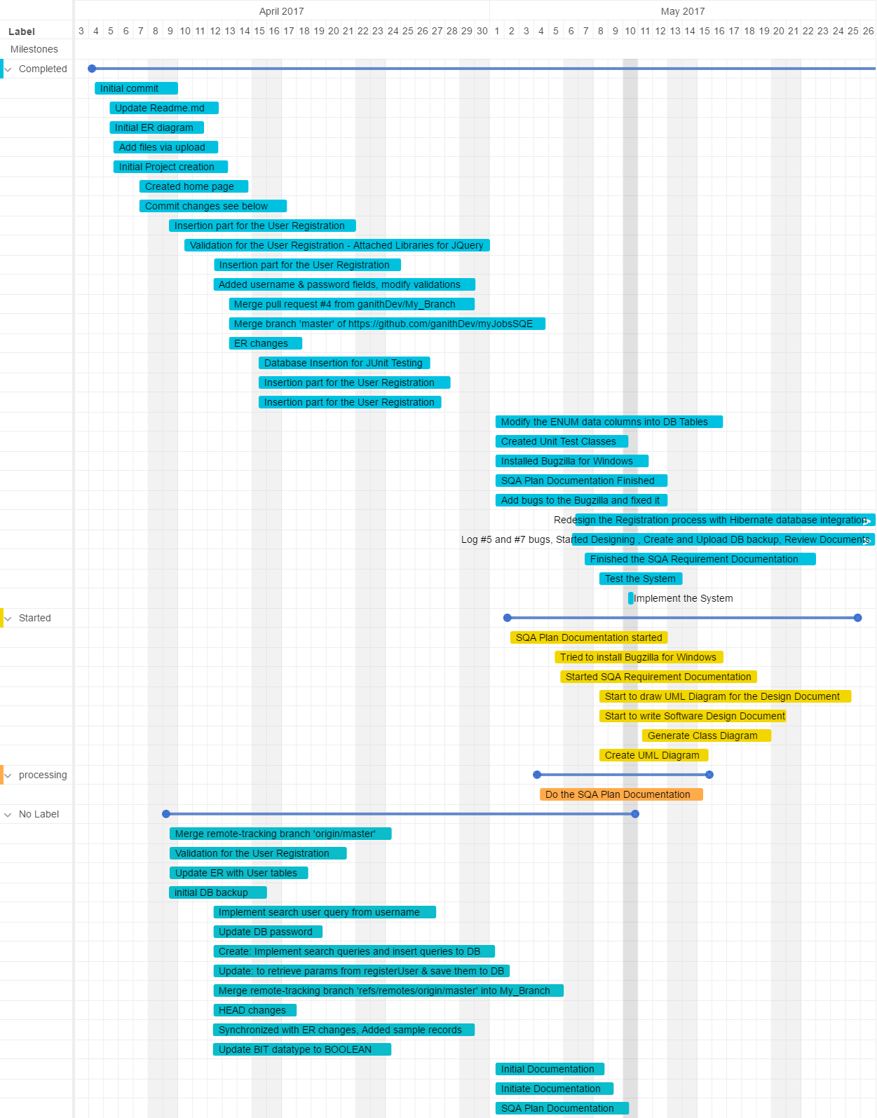

  - Project Schedule

The project schedule for the RecruitMe Application assigned to complete the tasks.

Date | Title | Status | Card Number | Member
Apr 4, 2017 | Initial commit | Completed | 1 | Ganith  Naduni
Apr 4, 2017 | Update Readme.md | Completed | 2 | Ganith
Apr 4, 2017 | Initial ER diagram | Completed | 3 | Ganith
Apr 5, 2017 | Add files via upload | Completed | 4 | Ganith  Naduni
Apr 5, 2017 | Initial Project creation | Completed | 5 | Ganith  Naduni
Apr 6, 2017 | Created home page | Completed | 6 | Ganith  Naduni
Apr 7, 2017 | Commit changes see below | Completed | 7 | Ganith  Naduni
Apr 9, 2017 | Insertion part for the User Registration | Completed | 13 | Ganith  Naduni
Apr 9, 2017 | Validation for the User Registration - Attached Libraries for JQuery | Completed | 12 | Naduni
Apr 9, 2017 | Merge remote-tracking branch 'origin/master' | Completed | 11 | Ganith
Apr 9, 2017 | Validation for the User Registration | Completed | 10 | Naduni
Apr 9, 2017 | Update ER with User tables | Completed | 9 | Ganith
Apr 9, 2017 | initial DB backup | Completed | 8 | Ganith
Apr 12, 2017 | Insertion part for the User Registration | Completed | 23 | Ganith
Apr 12, 2017 | Added username & password fields, modify validations | Completed | 22 | Ganith
Apr 12, 2017 | Implement search user query from username | Completed | 21 | Ganith
Apr 12, 2017 | Update DB password | Completed | 20 | Ganith
Apr 12, 2017 | Create: Implement search queries and insert queries to DB | Completed | 19 | Ganith
Apr 12, 2017 | Update: to retrieve params from registerUser & save them to DB | Completed | 18 | Ganith
Apr 12, 2017 | Merge remote-tracking branch 'refs/remotes/origin/master' into My Branch | Completed | 14 | Ganith
Apr 12, 2017 | HEAD changes | Completed | 15 | Ganith
Apr 12, 2017 | Synchronized with ER changes, Added sample records | Completed | 17 | Ganith
Apr 12, 2017 | Update BIT datatype to BOOLEAN | Completed | 16 | Ganith
Apr 13, 2017 | Merge pull request #4 from ganithDev/ My Branch | Completed | 24 | Ganith  Naduni
Apr 13, 2017 | Merge branch 'master' of https://github.com/ganithDev/myJobsSQE | Completed | 25 | Ganith  Naduni
Apr 13, 2017 | ER changes | Completed | 26 | Ganith  Naduni
Apr 15, 2017 | Database Insertion for JUnit Testing | Completed | 27 | Naduni
Apr 15, 2017 | Insertion part for the User Registration | Completed | 29 | Ganith
Apr 15, 2017 | Insertion part for the User Registration | Completed | 28 | Ganith
May 1, 2017 | Initial Documentation | Completed | 30 | Naduni
May 1, 2017 | Initiate Documentation | Completed | 31 | Naduni
May 1, 2017 | Modify the ENUM data columns into DB Tables | Completed | 32 | Ganith
May 1, 2017 | SQA Plan Documentation started | Started, Completed | 35 | Naduni
May 2, 2017 | SQA Plan Documentation | Completed | 33 | Naduni
03-05-2017 | Created Unit Test Classes | Completed | 34 | Ganith
03-05-2017 | Tried to install Bugzilla for Windows | Started, Completed | 38 | Naduni
04-05-2017 | Do the SQA Plan Documentation | Processing Completed | 36 | Naduni
04-05-2017 | Installed Bugzilla for Windows | Completed | 37 | Naduni
05-05-2017 | SQA Plan Documentation Finished | Completed | 39 | Naduni
05-05-2017 | Add bugs to the Bugzilla and fixed it | Completed | 40 | Naduni
05-05-2017 | Redesign the Registration process with Hibernate database integration. | Completed | 42 | Ganith
06-05-2017 | Started SQA Requirement Documentation | Started, Completed | 41 | Naduni
06-05-2017 | Log #5 and #7 bugs, Started Designing, Create and Upload DB backup, Review Documents | Completed | 43 | Ganith
07-05-2017 | Finished the SQA Requirement Documentation | Completed | 44 | Naduni
08-05-2017 | Start to draw UML Diagram for the Design Document | Completed | 45 | Naduni
09-05-2017 | Start to write Software Design Document | Completed | 46 | Naduni
09-05-2017 | Generate Class Diagram | Completed | 47 | Ganith  Naduni
09-05-2017 | Create UML Diagram | Completed | 48 | Naduni
09-05-2017 | Test the System | Completed | 49 | Naduni
10-05-2017 | Implement the System | Completed | 50 | Ganith  Naduni

